The National Network of Career Nursing Assistants
"Nursing Assistants Authors" Publications
3577 Easton Road, Norton, Ohio 44203

Spotlight on Nursing Assistant Authors
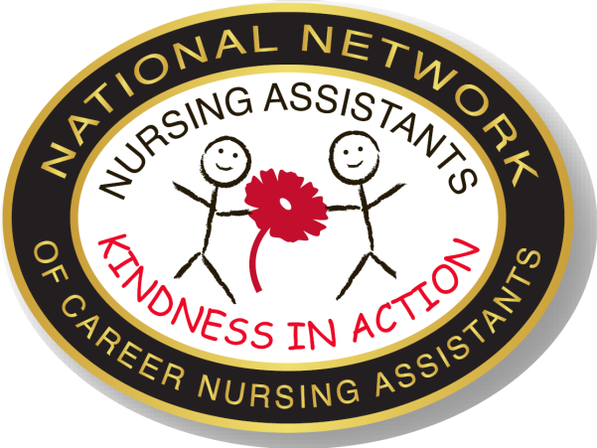
“Nursing Assistants:
Kindness in Action” ©

The 44th Annual National Nursing Assistants Week June 17-24, 202`
The 44th Annual National Career Nursing Assistants Day June 17, 202`

(Tips by Nursing Assistants for Nursing Assistant -Tips 12 ©)

"NURSING ASSISTANT AUTHORS"
CALL FOR ESSAYS AND PROJECTS 2020-21 and BEYOND
A Kindness Initiative
“In a world where you can be anything-be kind” Living with Special Needs Today.

Especially for: Nursing Assistants, Caregivers, Care Assistants, Home Care Aides, Geriatric Assistants, Resident Assistants, Patient Care Assistants, Restorative Aides, Health Care Assistants, and other direct care providers in Nursing Homes, In-Home Care, Hospitals, Hospice, Veteran’s Homes, Assisted Living, Prisons, schools and other Long Term Care Settings

- Share your wisdom and ideas for creating a caring and safe environment for workers and residents as well
- Help others understand the important work of the nursing assistant
- Become a published author
- Awards: 1st place - $50.00, 2nd place $30.00, 3rd place $20.00. Honorable mention- $10.00
- Help us develop an online collage on Facebook.

Nursing Assistants are Key Players in Care and interactions with patients, residents and clients are central to Caring. The words you use are powerful and can encourage, reassure, support, or convey respect and concern.

Many changes are occurring in health care today. Projects for NAWeek focus on Kindness in the care setting and are designed to help you showcase your skills and achievements and create new and positive ways to deal effectively new demands and opportunities. Our slogan is “Nursing Assistants: Kindness in Action”, to showcase your ideas about ways to make the care setting kinder and more homelike for patients and worker as well.

Work by yourself, with your team or committee, or with colleagues to create an essay, skit, song - write and submit or create an audiotape or videotape for one of more of the following.

ESSAY - Choose one or more of the following questions
- Tell us about a situation where kindness paid off for you with a patient or coworker.
- How do you help the people in your care form connections and become a part of the larger Community of Caring?
- How do you bring sunshine or kindness (a warm connection) to a person who is sad, or anxious or wandering?
- What do you say when ….he just needs someone to listen?
- What have you learned from the special people in your care?

SONG
- Create your own words to “You are My Sunshine” or other popular songs

Entries can be typed, handwritten or emailed, and must include your name, address and phone number. Please limit your essay to two paragraphs. If possible, enclose photos of those involved.

Submit your own entry - or work with other nursing assistant(s) to develop a Team Entry –
Please return by Dec 1, 2021(2021 Award) or by May 30,2021 (NAWeek Awards in June 2021) Also see Facebook
“Nursing Assistants: Kindness in Action” ©
A Kindness Initiative

Yes, we want to be a part of the “Kindness in Action” Campaign 2021-22 and Beyond

Complete this cover sheet and attach your essay or email to cnajeni@aol.com

Our Essay (song, rock, …title is ________________________________________________________________

Contact person___________________________________ Phone ____________________________________

Facility/Agency_________________________________________________PH (_____) _____________________

Address_______________________________________________________Email___________________________

City_____________________________________________________State_______________Zip______________

Attach your essay, photo, …. Use additional pages if needed. If sending photos, please identify individuals in the photo and how we can recognize them. Include your name and address on the back of the photo.

Type of entry: Individual NA entry____ Safety Committee Entry _____ NA Team Entry _____ other ___________
Ohio - Please return by Dec 1, 2021 (2021 Award) or by May 30,2021 (NAWeek Awards in June 2021)

NA Name | Title | Yrs of Service
(Add additional pages if needed)

Format: submitting: Essay____ photos____ audio tape____ video tape_____ On Facebook (date) ___________

Photo of our rock______ Slogan for Collage_______

How do you plan to use this for NA Week and throughout the year _________________________________________?

_____________________________________________________________________________________________

No cost to submit for awards

Ordering official lapel pin: “Kindness in Action” Authors Discount and free S&H when ordering with NAAuthors entry. ______________ (regular $3.99) $3.00/each )________ Amt Enclosed

Many ways to respond
- Email to cnajeni@aoal.com
- New fax # 330-319-7737.
- Post to Facebook National Network of Career Nursing Assistants. http://www.facebook.com/group.php?gid=118681892980
- Or mail completed entry to:
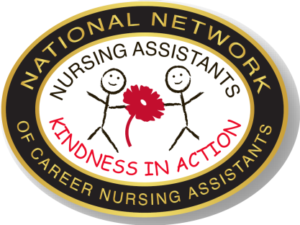
National Network of Career Nursing Assistants
3577 Easton Road
Norton, Ohio 44203-5661

Click and copy the logo to use for your own poster or publicity
May not be sold or used for profit
Questions about copyright contact cnajeni@aol.com or 330-825-9342

Career Nurse Assistants Programs, Inc (National Network of Career Nursing Assistants) is a non profit tax exempt professional organization for nursing assistants and other caregivers.
EIN# 34-17825218

